15.12: a) 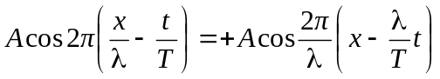
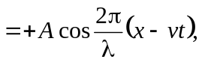

where 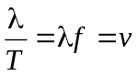 has been used.
- 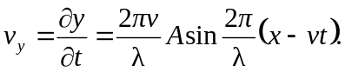
c) The speed is the greatest when the cosine is 1, and that speed is 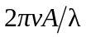. This will be equal to if 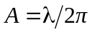, less than v if 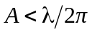 and greater than if 

